Case 5-Asia-China-Qijia-Bi Disc-3 Notch-Jade-Orange Red Bredigite-2200-1600 BCE

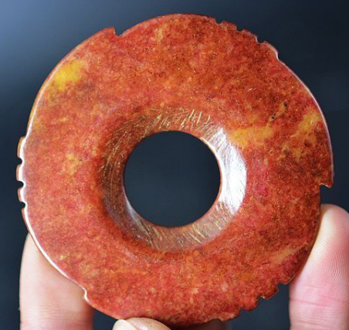 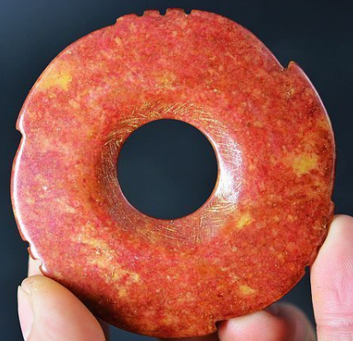

Figs. 1-2. China- China-Qijia-Bi Disc-3 Notch-Jade-Orange Red Bredigite-2200-1600 BCE

**Case no.: 5**

**Accession Number:**

**Formal Label:** China-Qijia-Bi Disc-3 Notch-Jade-Orange Red Bredigite-2200-1600 BCE

This Notched Bi Disc is attributed to the Late Neolithic Xia Period, Qijia Culture. It is composed of orange red Bredigite (Bredigite, oltrelite and iron schist) which renders a mostly opaque and uniform orange red color. It has 3 notches with 3 additional serrations, and its two sides are flat without any adornments. Its central hole is drilled from both sides. The identity of the notches has been suggested to relate to the three major asterisms of the Little Dipper: Polaris — also known by its genitive or possessive name, Alpha Ursae Minoris (alpha Mi) —at the end of the Little Dipper's handle, Kochab (beta UMi), and Pherkad (gamma UMi).

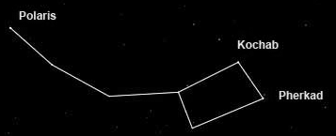

Fig. The three major asterisms of the Little Dipper after <https://www.space.com/28048-little-dipper.html>

The **Qijia Bronze Age Culture** (2200 BC – 1600 BC), was identified in 1923 by the Swedish archaeologist Johan Gunnar Andersson (1874–1960) in sites along the Tao River in Gansu province, but only in 1924 was it named after a site at Qijiaping, Guanghe county, Gansu. The jade artifacts from this culture are characterized by two major forms: the Bi or the Circular Disc that can also be notched and the Cong with its square, unadorned or ridged outer surface and hollow cylindrical inner core. The characteristic Qijia jade Bi and Cong is that they are mostly unadorned, leading scholars to surmise that there are no observable religious motifs associated with these forms. However, the two basic geometric forms of the Bi and Cong are the circle and the square, which, in associated cultures, especially the Liangzhu in the lower Yangtze area, are associated with Heaven and Earth respectively. If the Qijia did resume where the Liangzhu terminated in 2200 BCE, then it is reasonable to assume some cultural continuity, albeit without the engraved and bas-relief motifs cts that the Liangzhu jade artisans were so famous for producing.

**LC Classification: LC Classification:** NK5750.2.C6

**Date or Time Horizon:**

**Geographical Area:**

**Map:**

**Map:**

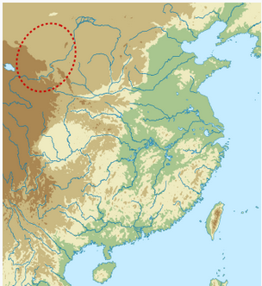

**https://upload.wikimedia.org/wikipedia/commons/thumb/a/ac/Qijia_map.svg/330px-Qijia_map.svg.png**

**GPS coordinates:**

**Cultural Affiliation:**

**Medium:** orange red jade

**Dimensions:** D in, T in

**Weight:**

**Condition:**

**Provenance:**

**Discussion:**

**References:**

Chen, Honghai. 2013. "The Qijia culture in the upper Yellow River valley". In Underhill, Anne P. A Companion to Chinese Archaeology. London: Blackwell, pp. 105–124.

Gu, Fang and Childs-Johnson, Elizabeth. 2008. *Jades of the Qijia and related northwestern cultures of early China, ca. 2100-1600 BCE* [project coordinator Jessica Curnoe]. New York: Throckmorton Fine Art